General Code for Take 4, Part 2:

% Rocket Project, Take 1

% Deepak Warrier

% September 22, 2016

clc;

clear all;

close all;

g = 9.8; % acceleration of gravity

thrust = 25000; % thrust of the rocket motor in Newtons (kg\*m/s^2)

rocketMass = 400; % mass of the rocket itself in kg

fuel = 1200; % mass of fuel in kg

burnRate = 2; % rate of rocket fuel burn in kg/second

mass = rocketMass+fuel; % mass of the rocket in kg

%burnTime = 30; % burn time of the rocket in seconds

stopTime = 10000; % time (in seconds) when the simulation stops

timeStep = 1; % time step size for the simulation (every 0.1 seconds)

v(1) = 0; % rocket velocity in m/s

vY(1) = 0; % Velocity in x direction

vX(1)= 0; % Velocity in y direction

downRange(1) = 0; % rocket downRange in m

altitude(1) = 0; % rocket altitude in m

time(1) = 0; % time since launch, in seconds

fuel(1)=fuel;

angle = 80;

earth = 6400000; % Earth's radius in meters

g(1) = 9.8; % acceleration of gravity

i=1;

while(max(time)<stopTime)

if(fuel(i)>0)

vY(i+1)=vY(i)+((thrust\*sind(angle))/mass-g(i))\*timeStep;

vX(i+1)=vX(i)+(thrust\*cosd(angle)/mass)\*timeStep;

else

vY(i+1)=vY(i)-g\*(timeStep);

vX(i+1)=vX(i);

end

avgVelY=(vY(i+1)+vY(i))/2;

avgVelX=(vX(i+1)+vX(i))/2;

v(i)=(vX(i+1)^2+vY(i+1)^2)^.5;

downRange(i+1)=downRange(i)+avgVelX\*timeStep;

altitude(i+1)=altitude(i)+avgVelY\*timeStep;

time(i+1)=time(i)+timeStep;

fuel(i+1)=fuel(i)-timeStep\*burnRate;

mass=rocketMass+fuel(i+1);

g(i+1)= ((earth^2)\*g(1))/((altitude(i+1)+earth)^2);

i=i+1;

end

printf('\n');

printf('Max Altitude: %.2f m\n', max(altitude));

printf('Max Down Range: %.2f m\n', max(downRange));

printf('Max Altitude: %.2f mi\n', (max(altitude)/1609.34));

printf('Max Down Range: %.2f mi\n', (max(downRange)/1609.34));

printf('Max Velocity: %.2f m/s\n', (max(v)));

printf('Max Velocity: %.2f mph\n', (max(v)\*2.23694));

%max(altitude)

%max(downRange)

%max(time)

plot(time, altitude, time, downRange);

title('Altitude/Distance v. Time @ 80 degrees');

xlabel('Time (in seconds)');

ylabel('Altitude/Distance (in meters)');

legend('Altitude','Distance');

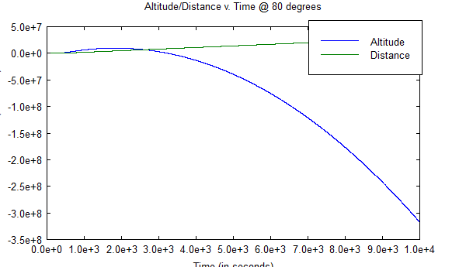

The rocket does eventually make it back to earth.

To use the simulation, I changed the loop condition from fuel to time, so that it runs till it hits the specified time. After the simulation runs, the plot will show me whether or not the rocket hit 0m altitude, which means the rocket has hit the Earth again.

General Output:

Max Altitude: 9724997.98 m

Max Down Range: 28947116.23 m

Max Altitude: 6042.85 mi

Max Down Range: 17986.95 mi

Max Velocity: 80138.21 m/s

Max Velocity: 179264.37 mph